Build Workflow: Vertical SME Operations Suite
Nov 1, 2026 · @David Akwu

1. Approach
The Phase 1 build runs for 13 weeks in six two-week sprints plus a pilot review week, with foundations built first and each module delivered as a complete, usable slice rather than as layers.
Working principles
- Foundations before features. Offline sync, roles and audit are built first because every module depends on them and they are costly to retrofit.
- Vertical slices. A module is done only when a pilot user can complete its real task end to end on a real device, not when its screens exist.
- Real devices, real conditions. Every sprint is demonstrated on a low-end Android phone with the network switched off.
- Pilot users in the loop from week 2. Design and build are reviewed with owners and attendants, not only with the team.
- Decide early, change late. Open decisions are closed at fixed checkpoints (Section 12) so the team never builds on an assumption.
- Money paths get extra care. Anything that touches payments, stock value or balances gets a second reviewer and automated tests before merge.
Before day one (open items that gate the start)
# | Item | Needed by | Status
D1 | First vertical chosen | End of week 1 | Open
D3 | Payment approach and provider shortlist | End of week 2 | Open
D5 | Build model and team confirmed (in-house, partner studio or hybrid) | Before week 1 | Open
T1 | Technology stack (mobile framework, local database, backend, hosting) | End of week 2 | Open; to be proposed by the lead engineer and approved by the product owner
P1 | 5 to 10 pilot businesses identified | End of week 2 | Open
L1 | Legal review of data protection and payment obligations started | Week 2 | Open
The PRD for this product holds the module requirements; this document turns them into a build sequence.

2. Team and roles
A core team of 5 to 6 can deliver Phase 1, and every module has one named owner so decisions never wait on a committee. Headcount and names depend on the build model (open item D5).
Role | Proposed count | Owns | Key outputs
Product owner | 1 (David Akwu) | Scope, priorities, acceptance, open decisions, pilot relationships | Backlog, acceptance sign-off, decision log
Lead mobile engineer | 1 | Mobile app, offline data layer, sync client | App builds, offline test results
Mobile engineer | 1 | Module screens and device integrations (printer, scanner) | Module UI, hardware support
Backend engineer | 1 to 2 | APIs, sync service, payments webhooks, reports, notifications | Services, data model, integrations
UX and UI designer | 1 (can be part-time) | Flows, prototypes, design system, usability tests | Prototypes, component library, test findings
QA engineer | 1 (can be shared with a developer early on) | Test plans, automation, device lab, release checks | Test suites, defect reports, release sign-off
Pilot success lead | 1 (can be the product owner at first) | Onboarding, training, weekly pilot visits, feedback capture | Pilot log, training material
Ownership by module (proposed)
Module | Business owner | Technical lead
M1 Sales and POS | Product owner | Lead mobile engineer
M2 Inventory | Product owner | Mobile engineer
M3 Payments and reconciliation | Product owner | Backend engineer
M4 Customers and suppliers | Product owner | Mobile engineer
M5 Books and reports | Product owner | Backend engineer
F1 to F5 Foundations | Product owner | Lead mobile engineer and backend engineer jointly
Decision rights. The product owner decides scope and priority. The technical leads decide how it is built. Anything touching payments, data protection or pricing is escalated to the product owner and, where needed, legal counsel.

3. Delivery workflow
Every stage ends at a named checkpoint, and the only loop is the two-week module sprint.
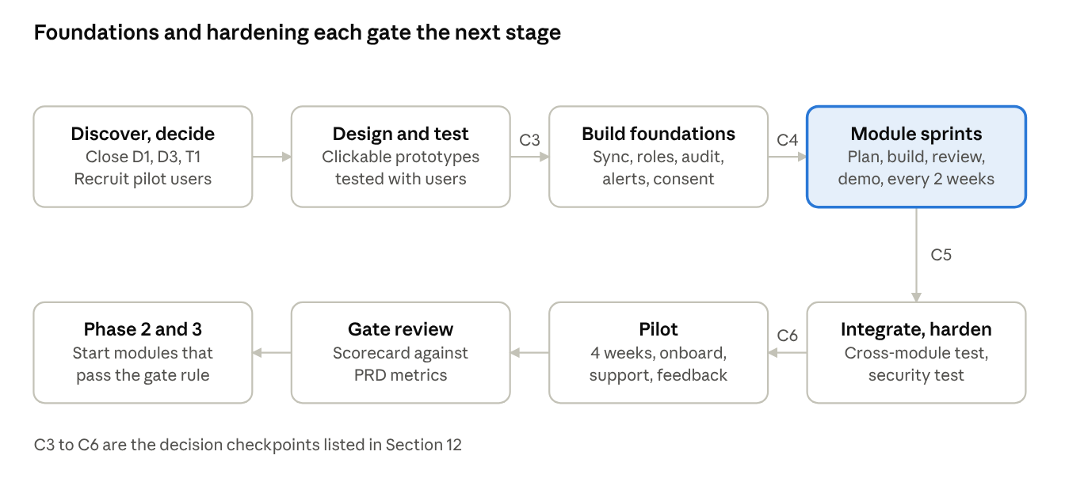
delivery workflow · 8 stages, 4 checkpoints
Row one runs left to right from discovery to the module sprints; row two continues right to left from hardening through the pilot and gate review to Phase 2 and 3.

4. Build order and dependencies
A slip in F1, M2, M1, M3 or M5 moves the pilot date, while the other items have room to move.
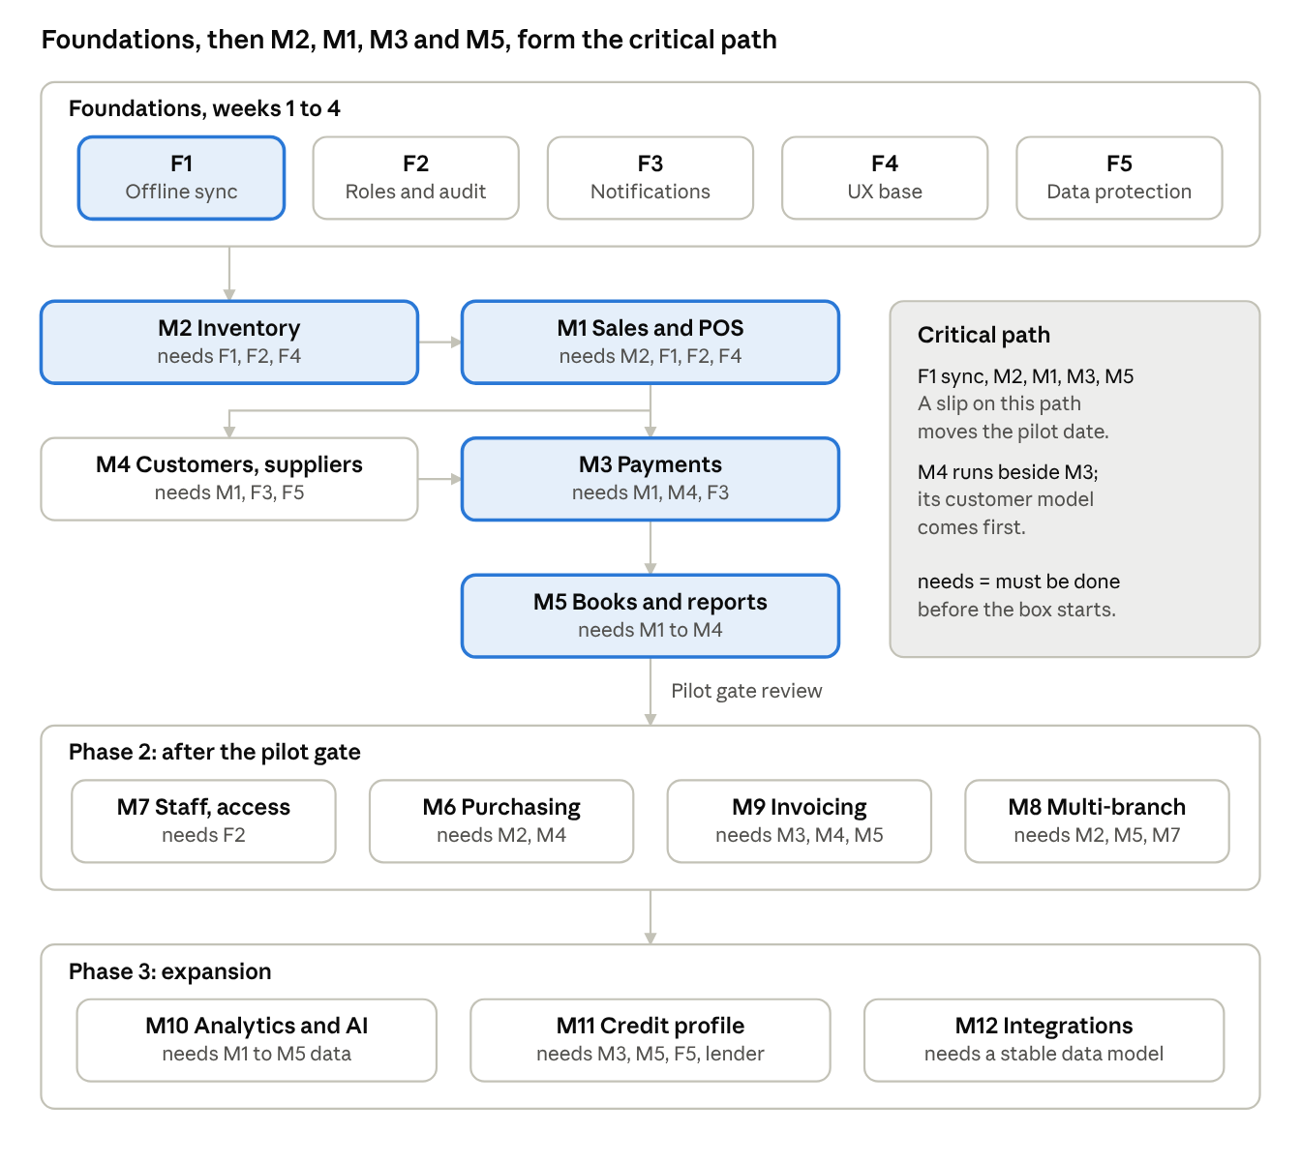
build order · 5 foundations, 12 modules
Each box lists what must be finished before it starts, and Phase 2 and 3 modules begin only after the pilot gate review.

5. Foundations workflow (weeks 1 to 4)
Five foundations are built in the first four weeks and are only called done when a module can sit on them without rework.
Foundation | Build steps in order | Owner | Output | Done when
F1 Offline data and sync | 1) Choose local database and data format (T1). 2) Define movement-based schema for stock, payments, balances. 3) Build local store with encryption. 4) Build change queue and retry logic. 5) Build sync service with idempotent writes. 6) Build conflict rules and device-prefixed numbering. 7) Build sync status screen | Lead mobile engineer, with backend engineer | Working local store, sync client and service, sync status chip | Two devices create sales offline, sync, and show identical totals with no duplicate numbers; interrupted sync resumes cleanly
F2 Identity, roles and audit | 1) Phone number sign-in with one-time code. 2) Device registration. 3) Role and permission model. 4) Screen and action guards. 5) Audit event writer on every change. 6) Owner device removal | Backend engineer | Auth service, role editor, immutable audit log | Attendant cannot open owner screens; every edit and void shows who, when and old and new value
F3 Notifications | 1) Push setup. 2) Message template system. 3) WhatsApp provider onboarding and template approval (starts week 2 because approval takes time). 4) SMS fallback. 5) Alert rules engine and quiet hours | Backend engineer | Notification service and approved templates | A test summary reaches a real WhatsApp number; alert fires on a low-stock test
F4 Localisation and UX base | 1) Design system with large-text and low-data modes. 2) Number pad and naira formatting. 3) String management for later languages. 4) First-use hints framework | UX and UI designer, mobile engineer | Component library and string files | Same screen passes readability check in bright light on a low-end phone
F5 Data protection | 1) Data inventory and purpose map. 2) Consent screens and consent log. 3) Encryption in transit and at rest. 4) Export and delete tooling. 5) Legal review sign-off | Product owner, backend engineer, legal counsel | Consent flow, data map, privacy notice | Counsel confirms obligations are met before pilot; export and delete tested
Rule. No module work starts on a screen that needs a foundation capability not yet marked done, with one exception: screens can be prototyped on mocked data while the foundation is finished.

6. Phase 1 module workflows
Each module follows the same seven-step pattern: design, data model, build, connect, test, pilot-check, sign-off. The tables below list what is specific to each module, in build order.

M2. Inventory and stock control (build first, because M1 needs the catalogue)
Step | Activity | Owner | Output
1 | Define product, unit and conversion model; agree vertical fields with the chosen vertical pack (D1) | Product owner, designer | Data dictionary, unit rules
2 | Prototype product list, add product and stock-in screens; test with 3 store clerks | Designer | Tested prototype
3 | Build catalogue screens and CSV import | Mobile engineer | Catalogue live in app
4 | Build stock-in with average cost update | Mobile and backend engineers | Stock movements with cost
5 | Build adjustments with mandatory reasons and stock count mode with variance approval | Mobile engineer | Count and variance flow
6 | Connect low-stock alerts to notifications (F3) and build stock value report | Backend engineer | Alerts and report
7 | Build batches and expiry tracking (Should) | Mobile engineer | Batch screens
Depends on: F1, F2, F4. Test focus: movements add up to the stock level on two devices; unit conversion accuracy; negative stock flags. Done when: the M2 acceptance criteria in the PRD pass on a low-end phone, and one pilot store has loaded its real catalogue.

M1. Sales and POS
Step | Activity | Owner | Output
1 | Prototype the 3-tap sale flow; time it with 5 attendants | Designer | Timing results and fixes
2 | Build product picker, cart, quantity and price editing | Lead mobile engineer | Sale entry working offline
3 | Build discounts, price floor and manager approval | Mobile engineer | Approval flow with audit entries
4 | Build payment choice, split payments and credit sales with customer attach | Mobile engineer | Payment capture states: paid, pending, credit
5 | Build receipts: WhatsApp, SMS and Bluetooth printer | Mobile and backend engineers | Receipt output on 2 printer models
6 | Build void and return with reversing entries for stock and payment | Lead mobile engineer | Reversal logic with tests
7 | Build held sales, device-prefixed numbering and end-of-day cash-up | Mobile engineer | Cash-up screen
8 | Run speed, offline and duplicate-number tests | QA engineer | Test report
Depends on: F1, F2, F4, M2 catalogue. Test focus: 15-second sale target, no duplicate numbers across offline devices, void restores stock exactly. Done when: a pilot attendant completes a full day of real sales with the notebook put away.

M3. Payments and reconciliation
Step | Activity | Owner | Output
1 | Confirm provider (D3) and obtain sandbox access; list provider limits and fees | Product owner | Signed sandbox terms
2 | Prototype payments inbox and unmatched queue; test with 3 owners | Designer | Tested prototype
3 | Build virtual account creation per business, branch or customer | Backend engineer | Account issuing service
4 | Build webhook receiver with signature check, duplicate protection and poll fallback | Backend engineer | Reliable payment confirmation
5 | Build matching engine: exact amount and reference, customer account, open-invoice amount, time window; record why each match was made | Backend engineer | Match engine with reason log
6 | Build unmatched queue with one-tap suggested matches; handle partial payments, overpayments and customer credit | Mobile and backend engineers | Resolution flows
7 | Build POS and USSD settlement import and payment links (Should) | Backend engineer | Settlement matching
8 | Build daily settlement report and fraud guards (confirmation only from provider) | Backend engineer | Settlement report
9 | Run sandbox tests, then small live payments with real bank accounts | QA engineer, product owner | Live test record
Depends on: F1, F2, F3, M1 sale records, M4 customer accounts. Test focus: duplicate and delayed webhooks, wrong amounts, two sales with equal amounts, provider downtime, match rate on a seeded test set. Done when: at least 80% of test transfers match automatically, no payment is ever lost, and a live payment confirms on the sale within seconds when online.

M4. Customers and suppliers (built in parallel with M3)
Step | Activity | Owner | Output
1 | Define customer and supplier model with consent flags | Product owner, backend engineer | Data model
2 | Build list, profile and contact import with consent | Mobile engineer | Customer and supplier screens
3 | Build ledger-based balances and ageing | Backend engineer | Balance engine
4 | Build credit limits and warnings | Mobile engineer | Limit rules
5 | Build reminders and statements, shareable on WhatsApp | Mobile and backend engineers | Reminder scheduler, statement generator
6 | Build purchase and payment history on profiles | Mobile engineer | Profile history
Depends on: F1, F2, F3, F5, M1 credit sales. Test focus: balance equals credit sales minus payments and returns to the naira; reminders respect opt-out. Done when: statements match the ledger and a pilot owner recovers a real debt using a reminder.

M5. Books and reports (built last in Phase 1)
Step | Activity | Owner | Output
1 | Build ledger posting from sales, payments, stock and expenses | Backend engineer | Ledger service
2 | Build expense capture with receipt photos | Mobile engineer | Expense screens
3 | Build reports engine: profit and loss, cash position, debtors and creditors, with drill-down to source records | Backend engineer | Reports hub
4 | Build daily summary content and scheduled WhatsApp delivery | Backend engineer | Daily summary
5 | Build day close and locked days with reasoned adjustments | Mobile and backend engineers | Day close flow
6 | Build CSV and PDF export and the bookkeeper read-only role | Backend engineer | Exports
7 | Compare report totals against hand calculations on real pilot data; have an accountant review | QA engineer, product owner | Reconciliation sign-off
Depends on: M1 to M4. Test focus: profit equals sales minus cost of goods sold minus expenses; every figure drills to its source; locked days resist silent edits. Done when: an accountant confirms the reports are correct on a pilot business's real week.
Integration test (end of week 10). One scripted scenario runs across all five modules on two devices, one of them offline: stock in, sales, a credit sale, a transfer payment, a return, an expense, day close, and the next morning's summary. All figures must reconcile.

7. Phase 2 and Phase 3 module workflows
These modules start only after the Phase 1 pilot review, and each one follows the same gate: five or more pilot businesses ask for it, or a measured problem justifies it.
Module | Starts when | Build steps in order | Done when
M7 Staff and access control | First, since pilots share phones and have staff | 1) Staff invite by phone. 2) Editable role permissions. 3) Per-attendant reports. 4) Shift open and close. 5) PIN and biometric lock | Owner sees sales, voids and cash variance per attendant for a full week
M6 Purchasing and suppliers | Pilots ask to order stock from the app | 1) Purchase order creation and WhatsApp send. 2) Receive goods against order. 3) Supplier price history. 4) Supplier payment scheduling | A pilot restocks entirely through purchase orders for 2 weeks
M9 Invoicing and tax support | Business customers need invoices | 1) Invoice and quote templates. 2) Invoice payment tracking through virtual accounts. 3) VAT and tax settings checked with an accountant. 4) Tax-ready exports | Invoice paid by transfer matches automatically and exports pass accountant review
M8 Multi-branch | A pilot opens a second outlet | 1) Branch model and permissions. 2) Stock transfers with in-transit state. 3) Consolidated and per-branch reports | Two branches trade for 2 weeks and consolidated totals reconcile
M10 Analytics and AI assistant | At least 60 days of data in several accounts | 1) Margin, slow-mover and demand reports. 2) Reorder suggestions. 3) Question box answering from the user's own data with source figures shown. 4) Accuracy review against manual answers | Answers match hand-checked figures in a test set of real questions
M11 Credit-readiness profile | Lender partner signed and consent flow approved by counsel | 1) Profile report from ledger and payments. 2) Consent, sharing link and revoke. 3) Lender referral flow and status tracking. 4) Security and privacy review | A real lender receives a profile and gives feedback on its usefulness
M12 Integrations and API | Stable data model and 3 partner requests | 1) API design with scopes and rate limits. 2) Webhooks. 3) Accounting and e-commerce connectors in order of demand. 4) Developer documentation | Three live integrations running with partners
The order of M6 to M9 is a proposal and can change with pilot feedback.

8. Sprint cadence and weekly rhythm
The team works in two-week sprints with a fixed rhythm, so the product owner always knows when decisions and demos are due.
Day | Event | Who | Output
Sprint day 1 (Monday) | Sprint planning, 1 hour | Whole team | Sprint goal, committed stories, owners
Every day | Stand-up, 15 minutes | Whole team | Blockers named and assigned
Mid-sprint (Wednesday of week 1) | Design and backlog check, 45 minutes | Product owner, designer, leads | Next sprint stories ready with acceptance criteria
Mid-sprint (Friday of week 1) | Pilot user session, 1 hour | Designer, product owner, 2 pilot users | Usability findings logged
Last Thursday | Device demo on a low-end phone, offline first | Whole team | Pass or fail against sprint goal
Last Friday | Sprint review and retrospective, 1.5 hours | Whole team | Accepted stories, improvements for next sprint
Backlog rules
- A story enters a sprint only with acceptance criteria copied from the PRD module requirement ID, such as M3-4.
- Each story is tagged with its module and foundation dependency.
- Defects found in the sprint are fixed in the sprint if they touch money, stock or balances; others join the backlog with a severity.
- At most 20% of a sprint is held for unplanned work.
Reporting. A one-page weekly update goes to the product owner every Friday: progress by module, risks, decisions needed, pilot feedback, and the next week's focus.

9. Quality gates and definition of done
A story is done only when it passes every check below, and a module is done only when its PRD acceptance criteria pass on a real low-end device.
Definition of done for a story
- ☐ Code reviewed by a second engineer (two reviewers for money, stock and balance logic)
- ☐ Unit tests written and passing; money paths have automated tests for edge cases
- ☐ Works offline and syncs without duplicates
- ☐ Role permissions checked, and an audit entry is written for every change
- ☐ Tested on at least two low-end Android devices
- ☐ Acceptance criteria from the PRD requirement ID verified by QA
- ☐ Product owner accepts in the sprint demo
Test layers
Layer | What it covers | When it runs
Unit tests | Calculations: pricing, discounts, average cost, balances, matching rules | On every commit
Integration tests | Sync between devices, webhooks, ledger posting, report totals | On every merge to the main branch
End-to-end scenario tests | The scripted cross-module scenario in Section 6 | Nightly and before each release
Device lab tests | Low-end phones, slow network, power loss mid-sale, app killed during sync | Each sprint demo and before pilot
Security tests | Authentication, role bypass, data exposure, dependency scan; external penetration test before pilot | Continuous scans; external test in week 11
Usability tests | Task timing and errors with real attendants and owners | Mid-sprint pilot sessions
Release gates
- Build gate: all tests pass and no open defect on money, stock or balances.
- Pilot gate: launch criteria in the PRD (Section 15) all ticked.
- Expansion gate: the pilot metrics in the PRD (Section 3) are met for four consecutive weeks.
Defect severity. Critical means wrong money, lost data or a blocked sale and is fixed before anything else; High means a workaround exists and is fixed this sprint; Medium and Low go to the backlog.

10. Pilot, release and feedback loop
The pilot is run like a second build stream: every business is onboarded the same way, every issue is logged by module, and a weekly decision turns feedback into the next sprint.
Onboarding steps for each pilot business
- Agree the pilot terms, success measures and a named owner contact (a written or paid commitment where possible).
- Do a physical stock count and record opening balances for stock, debts owed to and by the business, and cash.
- Load the catalogue (import or guided entry) and customer and supplier lists.
- Set up payment accounts and test one real transfer end to end.
- Train the owner and each attendant on site, using the in-app hints and a one-page guide.
- Run the notebook and the app in parallel for the first week, then compare totals daily.
- Switch fully to the app once two consecutive days reconcile.
Pilot weekly rhythm
Week | Focus | Owner | Output
1 | Parallel running, daily reconciliation against the notebook | Pilot success lead | Daily variance log
2 | Full use; fix top frustrations; first stock count with the app | Pilot success lead, QA | Count variance report
3 | Payments and debts focus; reminders sent; match rate review | Backend engineer, product owner | Match rate and recovered debt figures
4 | Reports and daily summary trust check; willingness-to-pay conversation | Product owner | Pilot scorecard against PRD Section 3 metrics
Feedback loop
- Every issue is logged with module, severity, business and device.
- Critical issues get a same-day fix or workaround; the rest are reviewed in a weekly 45-minute triage with the product owner.
- Feature requests are counted per module; a request from five or more pilots enters the next sprint planning (rule in Section 7).
- Each Friday update reports what changed because of pilot feedback.
Support model. A WhatsApp support line staffed in working hours, in-app help, and a named contact per pilot business. Support questions are tagged by cause (training, bug, missing feature) to show where the product or training needs work.
Early review (week 13) and gate review (about week 16). The product owner decides, with the team, whether to extend the pilot, widen it, or start Phase 2, using the scorecard and a list of unresolved critical issues. The week 13 review is an early check after the first pilot weeks; the formal gate review follows once pilots have run for four consecutive weeks, around week 16 if pilots start in week 12.

11. Tooling, environments and engineering practices
The specific tools are an open item (T1), so this section fixes the practices and the environments the team needs, and leaves the product choice to the technical leads.
Environments
Environment | Purpose | Data | Who uses it
Local | Day-to-day development | Test data | Engineers
Development | Shared integration and early demos | Test data, provider sandbox | Team
Staging | Release candidate checks, pilot rehearsals | Anonymised or seeded data, provider sandbox | QA, product owner
Production | Pilot and live businesses | Real data, live payment provider | Pilot businesses, support
Practices to adopt from week 1
- One repository per deployable part, with a short branch workflow and every change merged by pull request with review.
- Automated build, test and security scan on every pull request; a release build produced automatically for the device lab.
- Feature flags so unfinished modules can ship dark and be switched on per pilot business.
- Database changes through versioned migrations, and a sync version number so old app versions fail safely.
- Error and crash reporting, sync failure logs and payment webhook logs visible to the team from the first pilot day.
- Daily encrypted backups of production data with a restore test before pilot.
- Secrets and provider keys held in a managed vault, never in code.
- A decision log and a changelog kept up to date, so the product owner can see what changed and why.
Work tracking. One board with columns Backlog, Ready, In build, In review, In test, Accepted. Each card carries its module, PRD requirement ID, owner and foundation dependency.
Device lab. At least three low-end Android phones of different brands and ages, one Bluetooth receipt printer pair, one barcode scanner, and a network throttling setup that simulates 2G and outages.

12. Decision checkpoints and build risks
Six checkpoints decide whether the build can proceed, and a missed checkpoint moves the pilot date, not the quality bar. Every decision below is currently open.
Checkpoint | By | Decision needed | If missed
C1 | Before week 1 | D5 build model and team in place | Start date moves
C2 | End of week 1 | D1 first vertical | Vertical pack and pilot recruitment slip
C3 | End of week 2 | D3 payment approach, T1 stack, pilot businesses named, legal review started | M3 and foundations slip
C4 | End of week 4 | Foundations done: F1 sync demo passes on two devices | No module starts on unsafe ground; sprint 3 is spent on foundations
C5 | End of week 10 | Integration test passes | Hardening and pilot start slip
C6 | End of week 11 | Security test and launch criteria complete | Pilot does not start
Build risks and responses
Risk | Early signal | Response
Sync is harder than planned | Duplicate or missing records in week 4 demo | Cut scope elsewhere; give sync the best engineers; do not start M1 until it passes
Payment provider approval or sandbox delays | No sandbox access by week 3 | Start with the fallback of alert-based matching while approval completes; evaluate a second provider
WhatsApp template approval delays | Templates not approved by week 6 | Launch the daily summary by SMS and push first; add WhatsApp when approved
Pilot businesses drop out | Fewer than 5 confirmed by week 3 | Recruit through existing supply and trading relationships; widen to a second vertical only if the PRD gate allows
Team too small for the scope | Sprint commitments missed twice in a row | Cut Should items first (batches, payment links, POS settlement import); never cut audit, sync or reconciliation
Low-end device performance problems | Cold start or sale time over budget in sprint demos | Profile in the following sprint; add a performance story to every sprint
Scope creep from pilot requests | Requests outside the Phase 1 modules | Log, count, and apply the five-pilot rule in Section 7
Escalation. Any critical risk goes to the product owner within one working day, with the options and a recommendation.

13. Week-by-week plan for Phase 1
The plan reaches the pilot in week 12 only if the checkpoints in Section 12 are met on time; with a team of 5 to 6 it is a target, and a slip moves the pilot date, not the quality gates.
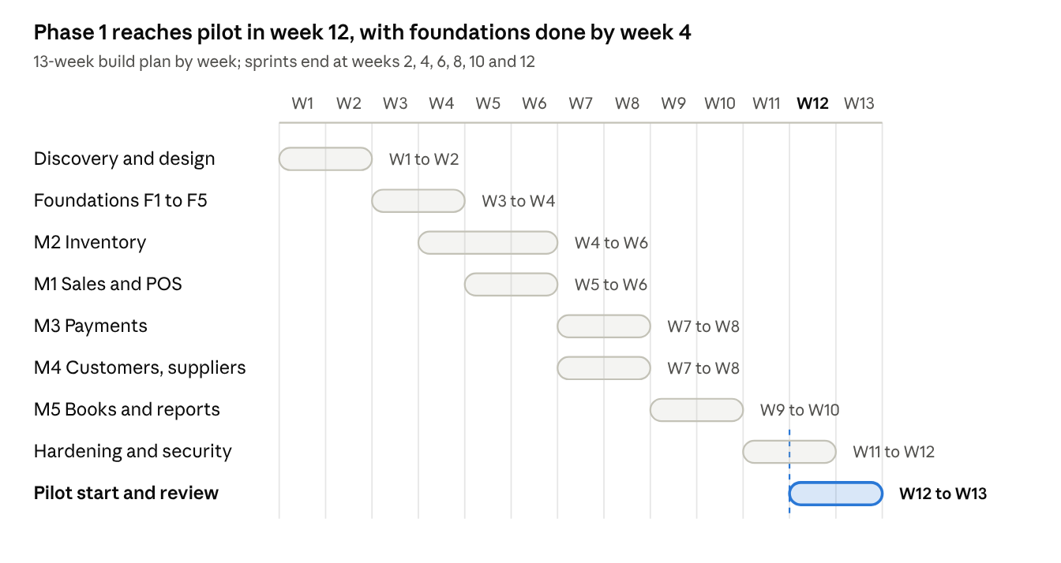
Phase 1 plan · 9 workstreams, 13 weeks
M2 starts in week 4 so the catalogue is ready when M1 begins in week 5, and M3 and M4 run in parallel with separate engineers. The formal pilot gate review follows after four consecutive pilot weeks.
Sprint | Weeks | Sprint goal | Demo on a low-end phone
1 | 1 to 2 | Decisions closed, prototypes tested, architecture agreed | Clickable prototype of Sell, Stock and Home
2 | 3 to 4 | Foundations done | Two devices sell offline and sync without duplicates
3 | 5 to 6 | Catalogue, stock and sales working | Full cash sale and receipt with the network off
4 | 7 to 8 | Payments, customers and balances | Live transfer matches a sale; credit sale and reminder
5 | 9 to 10 | Books, reports, daily summary, vertical pack | Scripted cross-module scenario reconciles
6 | 11 to 12 | Hardened, security tested, first pilots onboarded | Pilot business's first real trading day
Review | 13 | Early pilot review and Phase 2 priorities | Pilot scorecard

